**PRACTICAL – 05**

**5b) Create a JSP application to demonstrate the use of Expression Language**

**File Name: Index.jsp**

<%@page contentType="text/html" pageEncoding="UTF-8"%>

<!DOCTYPE html>

<html>

<head>

<meta http-equiv="Content-Type" content="text/html; charset=UTF-8">

<title>JSP Page</title>

</head>

<body>

**<%**

**application.setAttribute("author", "Richard Blum");**

**application.setAttribute("book", "Hardy Boys");**

**%>**

**<a href="Display.jsp">Click Here For Author Details</a>**

**<form action="Expression.jsp">**

**Student Name: <input type="text" name="sname" /><br>**

**Student Roll Num:<input type="text" name="rollno" /><br>**

**<input type="submit" value="Submit Details!!"/>**

**</form>**

</body>

</html>

**File Name: Display.jsp**

<%@page contentType="text/html" pageEncoding="UTF-8"%>

<%@page import="newpackage.*" %>

<!DOCTYPE html>

<html>

<head>

<meta http-equiv="Content-Type" content="text/html; charset=UTF-8">

<title>JSP Page</title>

</head>

<body>

**<h3>AUTHOR DETAILS</h3>**

**<b>Author name</b> <br>**

**${applicationScope.author}<br>**

**<b>Book name</b> <br>**

**${applicationScope.book}**

</body>

</html>

**File Name: Expression.jsp**

<%@page contentType="text/html" pageEncoding="UTF-8"%>

<!DOCTYPE html>

<html>

<head>

<meta http-equiv="Content-Type" content="text/html; charset=UTF-8">

<title>JSP Page</title>

</head>

<body>

**<h4>Student Data</h4>**

**Student name is ${ param.sname } <br>**

**Student Roll No is ${ param.rollno } <br>**

**<h4>Value Expressions</h4>**

**<b> Is 1 less than 2 ? </b> ${1<2} <br>**

**<b>Arithmetic expression 1+2+3 is </b> ${1+2+3}**

</body>

</html>

**Output:**

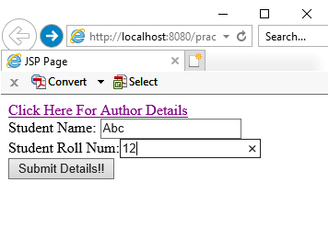 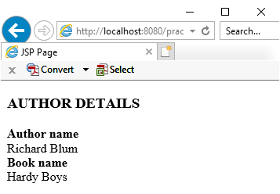

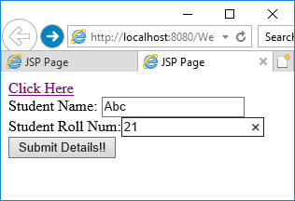 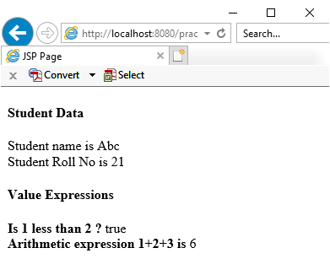

**5c) Create a JSP application to demonstrate the use of JSTL**

**File Name: Index.jsp**

<%@page contentType="text/html" pageEncoding="UTF-8"%>

<!DOCTYPE html>

<html>

<head>

<meta http-equiv="Content-Type" content="text/html; charset=UTF-8">

<title>JSP Page</title>

</head>

<body>

**<form action="TestServlet" method="POST">**

**<input type="submit" value="Submit JSTL" />**

**</form>**

</body>

</html>

**File Name: Student.java**

package newpackage;

public class Student {

**public String sId, sName;**

public Student(String sId, String sName) {

this.sId = sId;

this.sName = sName;

}

public String getsId() {

return sId;

}

public void setsId(String sId) {

this.sId = sId;

}

public String getsName() {

return sName;

}

public void setsName(String sName) {

this.sName = sName;

}

}

**File Name: TestServlet.java**

package newpackage;

import java.io.IOException;

import java.io.PrintWriter;

import java.util.ArrayList;

import javax.servlet.ServletException;

import javax.servlet.http.HttpServlet;

import javax.servlet.http.HttpServletRequest;

import javax.servlet.http.HttpServletResponse;

public class TestServlet extends HttpServlet {

protected void processRequest(HttpServletRequest request, HttpServletResponse response)

throws ServletException, IOException {

**ArrayList<Student> list=new ArrayList<Student>();**

**list.add(new Student("101", "abc"));**

**list.add(new Student("102", "pqr"));**

**list.add(new Student("103", "xyz"));**

**request.setAttribute("studentList", list);**

**request.getRequestDispatcher("Display.jsp").forward(request, response);**

}

@Override

protected void doPost(HttpServletRequest request, HttpServletResponse response)

throws ServletException, IOException {

processRequest(request, response);

}

}

**File Name: Display.jsp**

<%@page contentType="text/html" pageEncoding="UTF-8"%>

**<%@page import="newpackage.*" %>**

**<%@taglib prefix="c" uri="http://java.sun.com/jsp/jstl/core" %>**

<!DOCTYPE html>

<html>

<head>

<meta http-equiv="Content-Type" content="text/html; charset=UTF-8">

<title>JSP Page</title>

</head>

<body>

**<h3>STUDENT DETAILS</h3>**

**<table border="1">**

**<th>Student ID</th>**

**<th>Student Name</th>**

**<c:forEach items="${requestScope. studentList }" var="stud">**

**<tr>**

**<td>${stud.sId}</td>**

**<td>${stud.sName}</td>**

**</tr>**

**</c:forEach>**

**</table>**

</body>

</html>

**Output:**

